Configuring the Raspberry Pi for Star*DV |  | 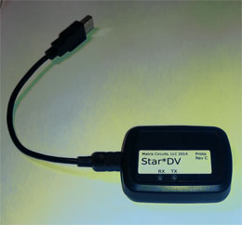
The Matrix Circuits Star*DV is a USB device that allows you to have D-STAR Digital Voice QSOs over the internet using a speaker/mike, headset or PC speakers/microphone. With the right software, you can also use it to adapt an analog radio to be able to have D-STAR QSOs over RF (for example, D-STAR on HF). The software can optionally work with a GMSK Modem to create a D-STAR Compatible Hotspot that also supports in-shack QSOs using a speaker/mike rather than a D-STAR HT.
This page shows how to install and configure the SDV-Pi software on a Raspberry Pi. This open source software was written by Rick KD0OSS of Matrix Circuits. He leveraged techniques and some code in the G4KLX suite, and some GMSK Modem code by KI4LKF. StarDV works with the G4KLX ircDDBGateway program, which manages linking and connecting to DPlus, DExtra and DCS reflectors as well as callsign routing using StarNET, CCS and ircDDB.
SDV-Pi requires that you have an LCD plate installed on the Pi before starting the program. All communication with you uses the LCD and the 5 buttons on the plate. Note: SDV has been tested with 3 LCD plates for the Pi: Adafruit monochrome LCD kit #1115, Adafruit RGB LCD kit #1110 and MoenComm monochrome built LCD with RGB status LED.
Load image file
First download and install the westerndstar image (click here) created by Brian, GW6WTK.
Configure G4KLX ircDDBGateway and the Western D-Star Widget
Use TightVNC to log onto your Pi's desktop. Password is raspberry.
GW6WTK's Widget makes it easy to configure G4KLX programs, and to control what is loaded automatically at bootup. When configuring the G4KLX programs, note that although there seem to be a lot of fields and options, in fact most of the default values are correct. There are only a few where you need to enter your own values, mainly callsigns.
Start the Widget by clicking on the Widget icon (found on the top line that begins with Menu)
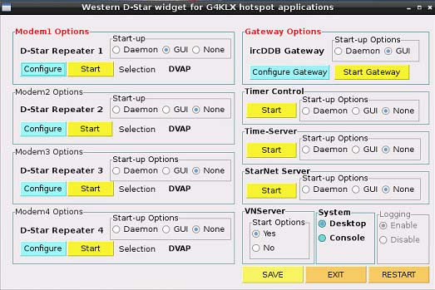
Configure the ircddbgateway program
- In the Widget, under ircDDB Gateway, click Configure Gateway button
  - Use screenshots at www.k6jm.com/ConfigG4KLX-DSR.pdf as a guide. Scroll down to shots showing ircDDBGateway on the top line.
  - Replace the sample callsigns with your own
  - On the Gateway tab, normally set Type to Dongle. If you are also using the optional GMSK Modem, set Type to Hotspot for simplex, or Repeater if duplex.
  - Latitude/Longitude/QTH/URL are optional. This info will appear on APRS status pages, if enabled, and on the ircDDB status pages, if enabled.
  - Fill in the first Repeater 1 tab. Band should be the same as selected for the D-Star Config program’s Callsign tab (B or C). Set Type to Homebrew. It’s not necessary to fill out the 2nd Repeater 1 tab.
  - Ignore the remaining Repeater tabs
  - Disable the ircddb tab unless you have a gateway callsign (or “club call”), have registered it with ircDDB and they have given you a password. Alternatively, you can read the Gateway manual about using the Italian test server.
  - If you want to link to DPlus REF reflectors, enable the DPlus tab. For callsign, fill in one that's a registered terminal at a US Trust connected D-Star gateway. Often this is the terminal with your callsign and a "blank" initial, or one with an N or R initial in the 8th position.
  - The remaining tabs can be ignored for now, except you may want to enable the Remote tab. See notes below for more info.
  - Go to File and select Save, then exit the program.
- In the Widget
  - Únder D-Star Repeater 1, in the Start-up box, click None. (When using StarDV, you don't want DStarRepeater launched at boot time.)
  - Click the SAVE button at bottom right of the Widget window.
  - Click the Restart button at bottom right of the Widget window. This will reboot your Pi.
Install & Configure SDV program 1st time -- click here
Using SDV
- Click here for SDV usage details
- Short version:
  - Install LCD plate on the Pi before booting up the Pi
  - Once SDV is running, press down button to scroll through menus:
Link -> Unlink -> Echo -> Info -> Configuration -> WiFi Config -> Shut Down -> Exit Menu
  - To select a function, click the Select button
  - Example: To link to REF012C
    - Press Down button to see Link command, then press Select button
    - Press Down button several times until REF012 is visable
    - Press Right button several times until C module is visable
    - Press Select button to do the Link
  - Speaker/Mike audio level (volume) controls -- There are two audio pots accessible on the back side of the Star*DV. The pot near the center controls the speaker level. The pot near the corner enclosure screw controls the mike level.
SDV source
SDV is open source software published under the GNU version 2 license. The source is available for download. Just join the stardboardt Yahoo Group and go to the Files area of the website.
D-Star® is a registered trademark used for communication equipment (repeaters and transceivers) for amateur radio communications, and owned by Icom Incorporated.

Loading the westerndstar GW6WTK Pi image |  | 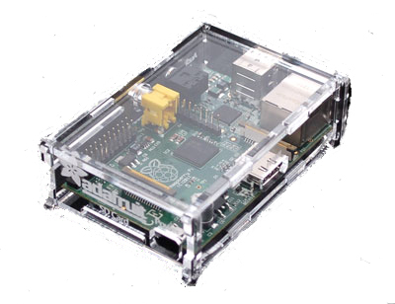  Raspberry Pi models B, B+, version 2 and later
Users of the Raspberry Pi have discovered image files that make setup fast and easy. One of the best is the popular westerndstar.co.uk Pi image file created and maintained by Brian GW6WTK. The fastest way to get up and running is to grab the image file from the internet and burn that to your Pi's SD card. Linux is already configured, and various applications are already installed. Note: Brian leverages work done by Hans DL5DI, who compiles G4KLX source with each new release and prepares Linux installation libraries.
The following assumes your main PC runs Windows. You can also accomplish all of the following using different commands and programs from a Linux PC or a Mac, but this page focuses on using Windows.
Getting Ready
- Use a high quality SD card. Most Pi problems originate with sub-standard or slow SD cards. Currently, SD cards are available marked "High Speed, up to 40 mb/s, used for DSLR". They don't have to be quite that fast, but these new cards are better than the original SD cards.
- There's no need to plug a monitor, keyboard or mouse into the Pi. Instead, you can log onto the Pi over your internal network. See TightVNC, below.
- Download and install the following PC programs that you'll use to set up your Pi:
  - TightVNC -- download from www.tightvnc.com/download.php
  - Win32DiskImager (used to write the image file to a memory card for the Pi) -- www.tightvnc.com/download.php
  - WinSCP (used to browse folders on the Pi, copy data to and from your PC) -- http://winscp.net/download/winscp551setup.exe
  - PuTTY (lets you log onto the Pi using an SSH command line window) -- http://www.chiark.greenend.org.uk/~sgtatham/putty/download.html
- If you plan to use a GMSK Modem with the Pi:
  - If your Modem uses DUTCH*Star firmware, you will need the Beta firmware version. Contact DUTCH*Star at fred@dutch-star.eu and give him your callsign and firmware license code.
  - Many people use a powered USB hub to plug the GMSK Modem card into, so the power doesn't have to come from the Pi itself. But many also just plug directly into the Pi. If you do that, and there are problems, you can always get a powered hub.
Write Image file to SD Card
Get the image file. Go to westerndstar.co.uk/html/downloads.html. Download the latest file. As of this writing, "Raspberry Pi Version 2 + Widget" is the latest and this page assumes that or later images. “D-StarRepeater+ircDDB+VNC+Widget” will also work, except on the new Pi 2. Unzip and burn the image to your SD card. Use Win32diskimager to burn the image to the SD card -- sourceforge.net/projects/win32diskimager/. Win32DiskImager tips:
- If you get an error message when opening the program, click ok to ignore and continue
- At the upper right, select the drive letter of your SD card reader/writer.
- Then click the folder icon to the left. Navigate to where the unzipped .img file is located and select that.
- Click the Write button.
- When complete, remove the SD card and carefully plug it into the Pi.
Log onto the Pi over your internal network using TightVNC
Plug in the network cable to the RPi and plug in the power. After a few moments, it will boot up and connect to your internal network. Check your router for the internal IP address assigned to this new device on your LAN. Start up the TIghtVNC Viewer (tvnviewer.exe). It will ask for the IP address of the Linux system you want to log on to. Use the Pi's IP address and add port 0.
< internal-IP>:0 – example might be 192.168.0.17:0. Password is raspberry.
The Pi’s desktop should then display. You will see that both DStarRepeater and ircDDBGateway programs are already running. Close both programs.
Change root password, configure WinSCP
Bring up LX Terminal (click on the terminal icon on the top line that starts with a Menu button). Type:
sudo passwd root
Give new root password twice.
Bring up WinSCP and set up a connection to your Pi. See notes, below, but here are the basics -- You will need your Pi's internal IP address. Use root as the username, and supply the password from above. Open the connection. You will see traditional folder navigation windows. The left is your PC; the right is your Pi. This is useful to learn about your Pi, to upload files if needed, and to edit text files directly. Since WinSCP is logged on as root, be careful. It is a good idea to make a copy of a file before changing it if you are not certain.
This is a good time to set up an SSH connection using PuTTY, using root and the above password. See this page.
At this point, you have three ways to browse, change and control your Pi. Mostly you will use TightVNC logged on to the graphical desktop as user Pi. Sometimes you may use WinSCP to navigate through directories, upload files or edit files. Sometimes you may SSH logon using PuTTY, to issue command line Linux commands. WinSCP and PuTTY logons will be as the root user.
Overscanning
If you can't see all of the program windows because of overscanning, use WinSCP to navigate to the /boot directory and alternate-click on file config.txt, then select Edit. Uncomment the two lines starting with "framebuffer". Exit WinSCP and save, then reboot the Pi by going to the TightVNC window, go to Menu > Shutdown, select Reboot and click OK.
You now have the image loaded onto your Pi and have access to various help programs. You will next want to configure the programs you will be using (G4KLX, ConDV, StarDV, etc).

Other details
Backup your SD card
- Once all is working, MAKE A BACKUP COPY of your SD card.
- Shut down the Pi, remove the SD card and plug it into your normal PC
- Run Win32DiskImager (ignore initial error messages)
- At the upper right, select the drive letter of your SD card reader/writer
- Click the folder icon to the left. Navigate to where you want to save your .img file. Enter the name of the file you want to save
- Click the Read button
WinSCP - A useful tool: A recommended tool is WinSCP. This graphical program allows you to logon to another Linux system like the Raspberry Pi and navigate through its directories, inspect files, and download or upload files between the Pi and your PC.
- Download it from here
- Once you have it installed and running, just click on New Site and set up the following:
  - File protocol: SFTP
  - Host name: The internal IP address of your Pi (e.g. 192.168.0.17)
  - Port number: 22
  - User name and password -- see note above in the PuTTY section. Common example is User = root, password = raspberry
  - Then click on the Save As button and give it a name
- Click on the Login button, and it will connect up and show you the Pi’s directories on the right half, and your own pc’s directories on the left.
- You can navigate to a file of interest and right-click on it. You'll have the option to download it to your PC, Edit it if it's in text format, select properties and change permissions, etc. It's a nice visual way to browse or change the files on your Pi.
D-Star® is a registered trademark used for communication equipment (repeaters and transceivers) for amateur radio communications, and owned by Icom Incorporated.

