
Pi-Star 3.4.10 – What’s New?
February 26, 2018 Michael Leave a comment Amateur Radio
A new version of Pi-Star is now showing up on Pi-Star installs. The release notes are below.
24-Feb-2018 **Version 3.4.10**
- NXDN has now been added to MMDVMHost, there is no NXDN Gateway service
yet, it will be coming soon. In the mean time the service has been hard coded to use the single public reflector for you to start using the service. Keep in mind
that NXDN IDs are 2 bytes long, 0-65533.
NXDNがMMDVMHostに追加されました.NXDNゲートウェイサービスはありません。近いうちにリリースされる予定です。 その間、あなたはサービスを使い始めるために単一のパブリックリフレクターを使用するようにサービスをハードコードしています。 NXDN IDの長さは2バイトで、0〜65533です
- P25Gateway & P25Parrot upgraded to the current release. This fixesa very minor long-standing P25Parrot bug, it also removes the logging requirement for the P25Parrot, removing the need for Pi-Star to maintain patches for the build process.
P25Gateway＆P25Parrotは現在のリリースにアップグレードされました。 これにより、P25Parrotのバグが修正され、P25Parrotのロギング要件が削除され、ビルドプロセスのパッチを維持する必要がなくなりました。
- YSFGateway & YSF25Parrot upgraded to the current release. This fixes a small update that removes the logging requirement for the YSFParrot, removing the need for Pi-Star to maintain patches for the build process.
YSFGateway＆YSF25Parrotは現在のリリースにアップグレードされました。 これにより、YSFParrotのロギング要件を取り除く小さなアップデートが修正され、Pi-Starがビルドプロセスのパッチを維持する必要がなくなりました。
- While working on this I found a related bug in the way that Pi-Star implements the YSFParrot that caused me some issues while testing the YSF2DMR. YSFParrot service handler and config have now been sorted out.
これに取り組んでいる間に、Pi-StarがYSFParrotを実装してYSF2DMRをテストしている間にいくつかの問題を引き起こしたというバグが見つかりました。 YSFParrotサービスハンドラと設定が整理されました。
- YSF2DMR binary has now been included, along with service handlers, this is
now fully integrated into Pi-Star.
YSF2DMRバイナリがサービスハンドラと一緒に含まれていますが、これは
Pi-Starに完全に統合されました。
- As usual these are all accompanied by MANY dashboard improvements…
Yes, you read that right, NXDN is now supported. There is just one reflector, but more will follow. Here is the configuration for NXDN:
いつものように、これらはすべて大胆なダッシュボードの改善を伴います...
はい、あなたはその権利を読んで、NXDNが現在サポートされています。 リフレクターは1つだけですが、それ以上のものは続きます。 NXDNの設定は次のとおりです。

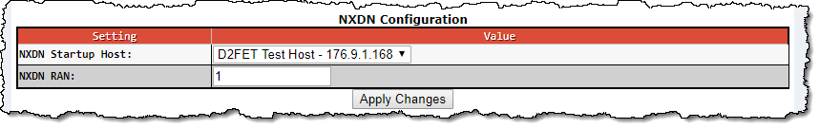
The YSF Configuration section has some new settings. To use DMR, in Wires-X mode change the reflector to YSF 00002.

118/5000

YSF設定セクションにはいくつかの新しい設定があります。 DMRを使用するには、Wires-XモードでリフレクタをYSF 00002に変更します。
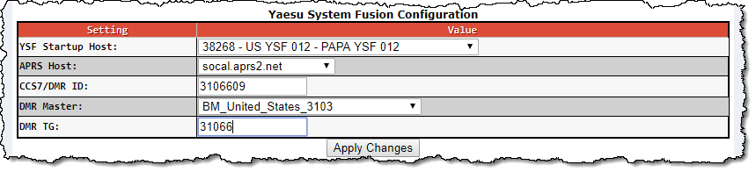

Andrew also posted about some of the features coming up:
3.5.0 Status – Delayed waiting for Raspbian Kernel update (4.9.48 should resolve the issues I have – waiting for that to be released as stable).
Working on:
- eMMC support in Odroid image
Completed:
- Make DStarRepeater dashboard more like MMDVMHost dash – Complete in the dashboard on the next major release.
- Port PiStar-Remote to DStarRepeater too – unified remote control.
- XRF host file update method (to use DPlus protocol or not)
- USB Tethering
- DMRGateway Upgraded
Next on the list:
- Better screen support – Support for the Adafruit Pi-Plate, have this working, needs dashboard integration.
- Add on-board tools for the Nextion – screen updating (probably in 3.5.0 release).
- Bluetooth PAN – Allow incoming Bluetooth local area network connection, to allow setup over Bluetooth from your phone, this should help the road warriors out there.
- Add multi-port option for web server, so that it can stay on 80 for local access but provide an alternate port for firewalls that can’t handle port translation on port forwards.
- Add user selection of dashboard color scheme.
- Add Static IP option on the dashboard.
- Crontab editor
To see the latest release notes and get the most current software, go to http://www.pistar.uk/downloads/

C4FMトランシーバーからDMRリフレクターを使用する方法（Pi-star C4FM2DMR）
2018/2/28 2018/3/3 DMRリフレクター, リフレクターの設定方法
C4FMトランシーバーからDMRリフレクターを使用する方法（Pi-star C4FM2DMR）
Pi-star 3.4.10において、C4FMトランシーバーを用いて、DMRリフレクターにアクセスするトランスコーディング機能が実装されました。（DMR無線機のかわりにC4FMトランシーバーが使用可能になる機能）
C4FM2DMR機能を使用するためにはPi-star 3.4.10とC4FMトランシーバーが必要です。
設定方法
Pi-starダッシュボード（右上）→「Configuration」をクリック
YSF Modeにチェック
YSF2DMRにチェック
設定後に「apply change」をクリックして保存します。
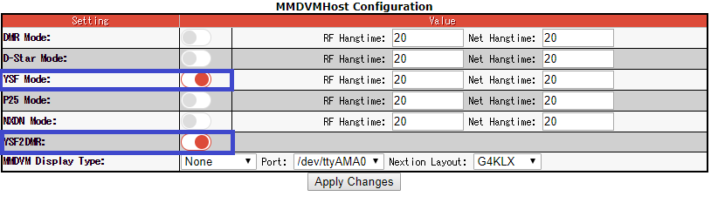

続いて、以下の設定を行います。
・YSF startup host：0002 YSF2DMR YSF2DMR Gateway
・CCS7 DMR ID：自身のDMR IDを設定
・DMR Master：BM 3108
・DMR TG：44120
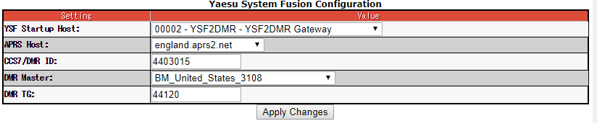
上記すべての設定を行ったのち、「apply change」をクリックします。
これですべての設定は終わりです。C4FMトランシーバーから電波を発信すると、DMR TG44120に接続され、DMR TGとしてワッチや送受信が出来ます。
(補足)
YSF2DMRはmmdvmとは独立したプロジェクトとして、約1月前から開発されてきました。わずかひと月での実装ですが、音声レベルや変調に問題は無く、DMR機と同様にきれいな変調で交信が可能です。トランスコーディング機能はソフトウェア上で実現されています。DMRトランシーバーをお持ちでない方でも、DMRの音声をや雰囲気を体験できます。ぜひお試しください。

What is Pi-Star?
Pi-Star is a custom, pre-configured SD Card image for the Raspbperry Pi (and other ARM based single board computers). Pi-Star is the whole image, it is made up of a number of software components, but Pi-Star is the sum of its parts.
While Pi-Star contains many new ideas, new features and interesting innovations, wherever possible the Pi-Star team push those developments back up-stream to the source of the systems/software in use, in doing so we make sure that everyone is able to benefit from our innovations.

Pi-Star's core is built on the excellent Raspbian linux distribution from the Raspberry Pi Foundation, even the non-Raspberry Pi foundation hardware also run Raspbian at the core to provide a uniform user experiance no matter what hardware you happen to be running.
The other major components that make up Pi-Star include the excellent software stacks by Jonathan Naylor (G4KLX) & others - MMDVMHost / DStarRepeater and associated tools / programs. This software stack is fairly feature complete (it's not complete, until its complete....) and contains many innovations and tools that are usefull to hotspot operators and repeater keepers alike.
The dashboard(s) in Pi-Star version 1 to version 3 (yes there are actually more than one) are forked and quite modified from their origional code, sourced from works by Hans Barthen (DL5DI) and Kim Hubel (DG9VH), however from Pi-Star version 4 and onwards uses a totally new dashboard that has been built from the ground up by Andy (MW0MWZ), adding in new features while trying to keep resource usage down - although the look will initially remain very much like the origional dashboard.
Along with the discrete software stacks and dashboard, Pi-Star uses the D-Star host files maintained by Adrian (VK4TUX), the Pi-Star update server pulls in those host files hourly for re-distribution to our users.
The final part of the system are in the form of the update mechanism, scripts and general wizadry that bind the whole system together, provided by Andy (MW0MWZ), all of these features come together to make Pi-Star what it is, when combined with the excellent support group hosted on Facebook, Pi-Star has become one of the go-to images for Digital radio on single board computers

Pi-Starは、Raspbperry Pi（および他のARMベースのシングルボードコンピュータ）用のカスタムの事前設定されたSDカードイメージです。 Pi-Starはイメージ全体であり、多くのソフトウェアコンポーネントで構成されていますが、Pi-Starはその部分の合計です。
Pi-Starでは、多くの新しいアイデア、新機能、興味深いイノベーションが含まれていますが、可能な限り、Pi-Starチームはこれらの開発を最新のシステム/ソフトウェアのソースに戻します。私たちのイノベーションの恩恵を受ける。

Pi-Starのコアは、Raspberry Pi Foundationの優れたRaspbian Linuxディストリビューションをベースに構築されています。ラズベリー以外のPi基盤ハードウェアでも、Raspbianをコアで実行して、実行中のハードウェアに関係なく一貫したユーザエクスペリエンスを提供します。
Pi-Starを構成するその他の主要コンポーネントには、Jonathan Naylor（G4KLX）＆MMDVMHost / DStarRepeaterと関連するツール/プログラムによる優れたソフトウェアスタックが含まれます。このソフトウェアスタックはかなり機能が完備されています（完了までは完全ではありません）。また、ホットスポットオペレータやリピータ保持者にも便利な多くの革新とツールが含まれています。
Hans Barthen（DL5DI）とKim Hubel（DG9VH）の作品を元にして、Pi-Starバージョン1からバージョン3のダッシュボード（実際には複数あります）は、元のコードからかなり変更されていますが、 Pi-Starバージョン4以降では、Andy（MW0MWZ）が最初から構築したまったく新しいダッシュボードを使用し、リソースの使用量を抑えながら新しい機能を追加していますが、外観は当初はダッシュボード。
個々のソフトウェアスタックとダッシュボードに加えて、Pi-StarはAdrian（VK4TUX）によって管理されているD-Starホストファイルを使用します。Pi-Starアップデートサーバーはユーザーに再配布するために毎時ホストファイルを取得します。
システムの最終部分は、Andy（MW0MWZ）によって提供されるシステム全体を結びつける更新メカニズム、スクリプト、一般的な情報の形態であり、これらの機能はすべて、Pi-Starを組み合わせてPi-Starは、優れたサポートグループをFacebook上でホストしているため、シングルボードコンピュータ上のデジタルラジオのゴーイングイメージの1つになっています

Who is behind Pi-Star?
To understand where Pi-Star is today, it's important to understand where it came from, and why...
In 2014 Andy (MW0MWZ) bought a DV-Mega board from Guus (PE1PLM), at about the same time he downloaded a ready to run image for the Raspberry Pi that had all the software pre-loaded. Andy has been a systems admin for a long time, and while the image worked, Andy felt the need to pull it apart and find out exactly what was going on under the hood.
Soon after, frustration set in, what better way to learn than to make your own... and so the Pi-Star project born, the first major goal was to slim down the image as much as possible, nothing else was even concidered at this point. Raspbian went on a strict diet and everything non-essential was out, the GUI and VNC were both on-board in the initial release, and there was no dashboard at this point. Andy showed his work to some local hams, but there really was not much interest, at this point Pi-Star did not offer any complelling reason to use it over any other image available.
Pi-Star Version 2 saw a full rebuild with the new Jessie version of Raspbian, the GUI was gone, the dashboard by Hans (DL5DI) was included, and the basics of the config page was included. The image was now a very small 400MB or so, now that was in order the focus shifted to making the config page as simple as was possible. After some testing with local hams the config page had the bare minimum of options to make a working D-Star hotspot.
For a while, there were only minor changes to Pi-Star, until early in 2016, Andy heard that DMR was now available using the DV-Mega board, some investigation lead Andy to MMDVMHost, and that meant lots of changes to Pi-Star. At the time, every change to the image meant a new image, develpment moved at a slow pace, but changes were quite large, the dashboard could only change the config files based on line numbers and this made for some real pain when new features made it into MMDVMHost.
Adrian (M0GLJ) found Pi-Star in early 2017, he asked Andy to formally release Pi-Star, until this time Pi-Star was avalable on Andys website, but only a handfull of people knew it existed, for a few weeks some large changes were pushed into Pi-Star and for a while a number of images per week were released while the new look of the dashboard was created, the dashboard was updated to stop the dependancy on line numbers and some of the long-standing issues that until this point nobody had cared about, were fixed up.
2017 has been a big year, the Pi-Star team grew to three core members, Andy (MW0MWZ), Adrian (M0GLJ) and Craig (W1MSG) - updates became automated and FREQUENT as new features have been added and existing ones updated. Through 2017 the number of people using Pi-Star grew from somwhere around 20 to somwhere around 3000, this explososive increase in users has not been without its challenges, but the project has been great fun so far and shows little signs of slowing down.
And now you understand where Pi-Star came from, why, and who did it. Thank you for reading, and enjoy Pi-Star, there is alot of the whole team in the software, we all hope you enjoy it!
Good luck, the Pi-Star Team

How can I help?
Like many other open-source projects, Pi-Star has been created by one person, as the project has grown, the team behind Pi-Star has grown too; there are now a number of "Moderators" who are helping out in the facebook group, Adrian (M0GLJ) taking the lead role in advertising and Andy (MW0MWZ) building the software, scripts and code that makes the project what it is.
There are many other contributions to the project through it's life, please see here for a list of people who have already contributed to the project.
Below is a list of hardware that this project currently needs most;
Raspberry Pi 3
Raspberry Pi Zero W
Yaesu Fusion Radio - Any Yaesu radio that supports System Fusion
SD Cards 4GB Class 10 or larger
Motorolla UHF Radio for creating a test repeater / gateway

Of course you may not have any of the above hardware spare, in that case we are always greatful of monitary contributions toward to the running costs of the server / build / test environments that are used to make Pi-Star what it is; you may use the following link in order to help us out. All donations will be recorded on the contributors page.

http://www.pistar.uk/downloads/#
